**MINOR REPORT**

**ON**

**LIBRARY MANAGEMENT SYSTEM**

**Submitted as partial fulfillment of**

**MASTER OF COMPUTER APPLICATION**

**DEGREE**

**SESSION 2022-23**

**By**

**Ankit Singh (2100320140029)**

**Under the guidance of**

**Mr. Amit Goel Mr. Tarun Kr. Sharma**

**Mr. Rajesh Kumar Maurya**

**(Project Coordinator) (Internal Guide)**

**ABES ENGINEERING COLLEGE, GHAZIABAD (032)**



**AFFILIATED TO**

**Dr. A.P.J ABDUL KALAM TECHNICAL UNIVERSITY, UTTAR PRADESH, LUCKNOW**

**STUDENT DECLARATION**

We hereby declare that the work being presented in this report entitled **“Library Management System”** is an authentic record of our own work carried out under the supervision of **“Mr. Rajesh Kumar Maurya”.**

**Date: Signature of Student**

Ankit Singh

This is to certify that the above statement made by the candidates is correct to the best of my knowledge.

**Signature of HOD Signature of Internal**

**Prof. (Dr.) Devendra Kumar Mr. Rajesh Kumar Maurya**

**HOD-MCA Asst. Prof. (Sr. Scale)**

Date:

ACKNOWLEDGEMENT

We deeply express our sincere thanks to our , **Mr. Rajesh Kumar Maurya (Faculty)** for encouraging and allowing us to present the project on the topic ***“Library Management System”***at our department premises for the partial fulfilment of the requirement leading to the award of MCA degree. We take this opportunity to thank all our lectures which helped our project. We pay our respects and love to our parents and teachers and friends for their love, support and encouragement throughout the career.

Ankit Singh (2100320140029)

**ABSTRACT**

This report includes a development presentation of an information system for managing the staff data within a small company or organization. The system as such as it has been developed is called Library Management System. It consists of functionally related GUI (application program) and database.

**TABLE OF CONTENTS**

1. Introduction

1.1 Overview & Problem Statement

1.2 Purpose

1.3 Scope

1.4 Definitions, Acronyms and Abbreviations

1.5 Tools Used

1.6 Methodology

1.7 Technologies to be used

2. Overall Description

2.1 Product Perspective

2.2 Software Interface

2.3 Hardware Interface

2.4 Communication Interface

2.5 Constraints

2.6 ER Diagram

2.7 Data Flow Diagrams

2.8 Architecture Design

2.9 Database Design

3. Supporting Information

4.1 Screen Shots

4.11 Forms

4. Testing

5. Implementation

6. Future Enhancements

7. Conclusion

8. Bibliography

**INTRODUCTION**

**1.INTRODUCTION**

**1.1Overview & Problem Statement**

ABOUT PROJECT

Welcome to "LIBRARY MANAGEMENT SYSTEM". It is a destination of books on a wide range of subjects. Our objective is to make a better place for online book shopping in NCR(National Capital Region)of India. This store is helpful for students, teachers, kids, senior citizens etc.

We aim to provide our customer alike with the best titles at the most affordable prices. We save your time by allowing you to place an order online. We save your money by offering a service of free shipping. When you find a book you like ,you can buy it directly online with an advantage to pay cash on delivery. We offer substantial discounts on a massive range of titles. We provide a personalized customer service ,you can speak to us and we resend to your email queries.

Every book purchased from "LIBRARY MANAGEMENT SYSTEM" contributes to individual literacy throughout the world and potential for a better life. Clearly we can't do this work without our customers .That's why we are so passionate about trying to offer the best price, selection, customer service and overall shopping experience. We are small and growing ,your feedback is highly appreciated.

CURRENT SYSTEM

In our day today life, we will need to buy a lots of books from a shop. Now a days, it is really hard to get some time to go out and get them by ourselves due to busy life style or lots of works.

LIMITATIONS OF CURRENT SYSTEM

This existing system of buying books has several disadvantages:-

* It requires lots of time to travel to the particular shop to buy the books.
* Since everyone is leading busy life now a days, time means a lot to everyone.
* Also there are expenses for travelling from house to shop.
* Moreover the shop from where we would like to buy some books may not be open 24*7*365.
* Hence we have to adjust our time with the shopkeeper’s time or vendor’s time.
* A lot of precious time is wasted in a process to buy a book like firstly reaching to bookstore,then waiting for our turn to buy a book as some other customers do already buying books.
* Sometimes,we are also not able to choose a worthwhile book from a variety of books at shop in a small pace of time.
* We are also not able to read an overview of a book before making a payment if there is too much rush on the bookstore

So ,the 2 important factors ie money and time are being violated in the existing system of buying books.

PROPOSED SYSTEM

In order to solve the problem of buying books from shops, LIBRARY MANAGEMENT SYSTEM have been started. Using website like this, we can buy Books online just by visiting the website and ordering the Books online with an advantage to pay cash on delivery instead of online payment. The proposed system will also provide service of free shipping in Delhi and NCR regions.Thus, we have e-commerce solution, i.e one place where we can get all Books online. The proposed system helps in building a website to buy, sell Books online using internet connection. Purchasing of Books online, user can choose different Books based on categories , delivery servicesetc. and hence covering the disadvantages of the existing system.The proposed system will make the buying books easier and helping the vendors to reach wider market.

BENEFITS OF PROPOSED SYSTEM

* Choose Books faster and easier at one place.
* Saves time of travelling to the vendor/seller’s place.
* Good/Trusted & Tension free delivery services.
* Products bought online will be delivered to the footsteps of the buyer free of cost.
* Alerts and real time reporting through Emails (to both vendor as well as buyer).
* Reports generated can be saved for future references.
* Tracking of placed order status before it is delivered.
* Inventory reports for the vendor/seller on daily, monthly, yearly basis.

PROBLEM STATEMENT

The project is to design and implement an online bookstore: “LIBRARY MANAGEMENT SYSTEM”. The bookstore will have two types of users namely the buyers, the administrator. Both of them will log in to the website using a unique user name and password. New users can register themselves to bay a book by clicking on a link “register here” displayed on the menu bar at the homepage . After logging , a welcome message containing the name, must be displayed for all users. The other functionality expected for each user is given in detail below.

**Buyers:** The buyer will be able to view the catalogue of books of different categories. They will also be able to search for books based on the author name .If a user wants to purchase a book, then he will first do login and then he can add selected books to the shopping cart. A link to the cart to be shown at the time when user clicks on “book detail” or “to buy” button. The books which user selects to buy will get added to the shopping cart. When the user want to place the order, he will click on the link “checkout”. Then, the order summary page will generate. If user want to finish the buying process ,he will click on the “continue” button. Then a receipt will be generated which contains a buyer’s reference id to track the order status in future. The buyer will give payment in cash on delivery. The users will be able to track their shipment, based on this tracking number.

**Administrator:** The administrator will be able to add, update and delete book information. He will also be able to view the stock details of books. He will also be able to view the orders being placed by users and what is their status. He will able to edit status of the orders as completed or pending.

**1.2 Purpose**

**“LIBRARY MANAGEMENT SYSTEM”** is a web application which provides online book shopping services to its customers at their doorstep. It is a destination of books on a wide range of subjects. The objective is to make a better place for online book shopping in NCR (National Capital Region) of India. This store is helpful for students, teachers, kids, senior citizens etc.

We aim to provide our customer alike with the best titles at the most affordable prices. We save your time by allowing you to place an order online. We save your money by offering a service of free shipping. When you find a book you like ,you can buy it directly online with an advantage to pay cash on delivery.

**1.3 Scope**

The “LIBRARY MANAGEMENT SYSTEM” with dynamic functionality has the following scope:-

Most generic consumer to consumer Library Management System which covers almost all possible categories of Books and their availibility. Maximize benefits and minimize the disadvantages of Online Book shopping.

* User friendly environment.
* provide facility of searching of books
* user can place order to buy books
* tracking of order status by user and admin.
* Manage all the account details such as user name, phone numbers, address, email addresses of the entire customer from one central location.
* Manage all the details regarding features of the books such as author, book dimension, book cost,number of pages,edition etc.
* Track all the customers and their contact details.
* Confirmation of end user identity and will verify which users are authorized to receive support.

**1.4 Definitions, Acronyms and Abbreviations**

**HOB**

Library Management System It’s a web application that provides online book purchasing services for people.

**Admin**

Administrator. He has the authority to manage book data i.e add/delete/edit books, manage order process

**MySQL**

MySQL is an open source relational database management system based on Structured Query Language

**DB**

A database management system that provides a flexible and efficient database

platform to maintain records of customers, admin, books, order and feedback details

**HTTP**

Hypertext Transfer Protocol.It’s a service protocol.

**UI**

User Interface

**1.5 Tools Used**

XAMPP

XAMPP is a free and open source cross platform web server solution stack package, consisting mainly of the Apache HTTP Server, My SQL Database and interpreters for scripts written in the PHP and Perl programming languages.

Officially, XAMPP's designers intended it for use only as a development tool, to allow website designers and programmers to test their work on their own computers without any access to the Internet.

XAMPP 1.8.3-4 for Windows, including:[[4]](http://en.wikipedia.org/wiki/XAMPP#cite_note-4)

* Apache 2.4.9
* MySQL 5.6.16
* PHP 5.5.11
* phpMyAdmin 4.1.12
* FileZilla FTP Server 0.9.41
* Tomcat 7.0.42 (with mod_proxy_ajp as connector)
* Strawberry Perl 5.16.3.1 Portable
* XAMPP Control Panel 3.2.1 (from hackattack142)

**1.6 Methodology**

Prototyping Model

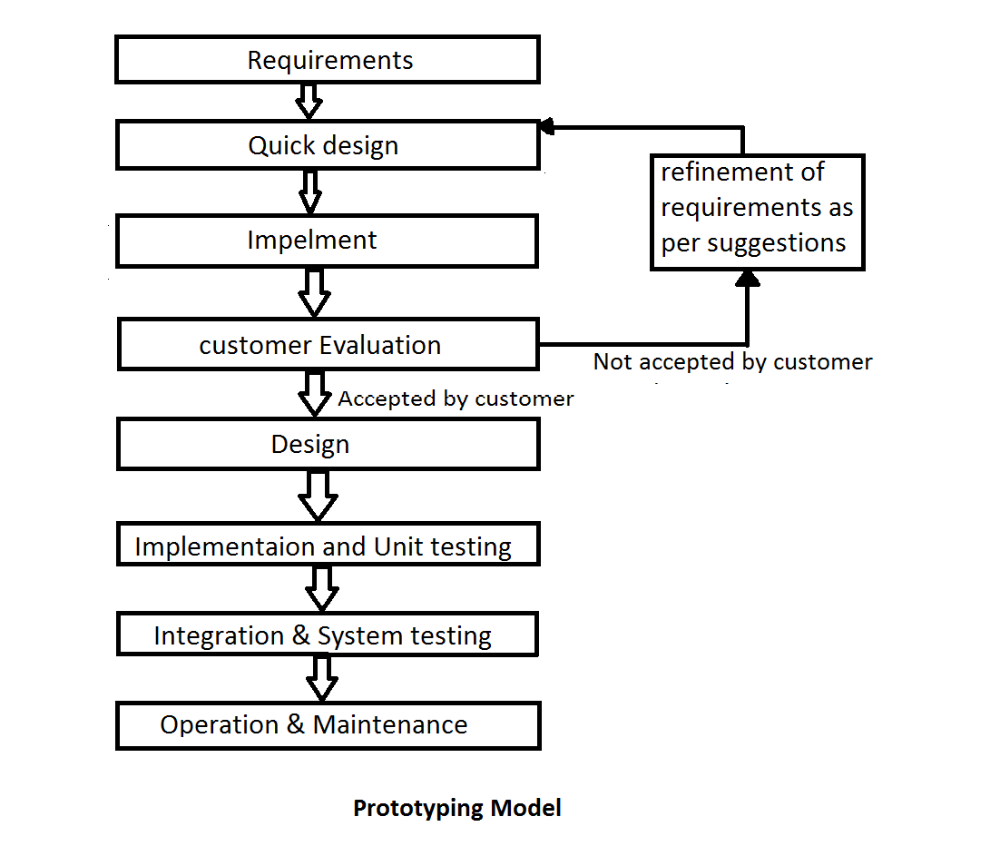

In Prototyping Model, Prototype is used to refine the requirement and prepare the final specification document. Because the working prototype has been evaluated by the customer, it is reasonable to expect that the resulting specification document will be correct. When the prototype is created, it is reviewed by the customer. Typically this review gives feedback to the developers that helps to remove uncertainties in the requirements of the software, and starts an iteration of refinement in order to further clarify requirements as shown in Fig..

The code for the prototype is thrown away; however the experience gathered from developing the prototype helps in developing the actual system. The development of a prototype might involve extra cost, but overall cost might turnout to be lower than that of an equivalent system developed using the waterfall model.

After the finalization of software requirement and specification (SRS) document, the prototyoe is discarded and actual system is then developed using the waterfall approach. Thus, it is used as an input to waterfall model and produces maintainable and good quality software.

**1.7 TECHNOLOGIES USED**

* HTML

HTML is written in the form of HTML elements consisting of *tags* enclosed in angle brackets (like <html>). HTML tags most commonly come in pairs like <h1> and </h1>, although some tags represent *empty elements* and so are unpaired, for example <img>. The first tag in a pair is the *start tag*, and the second tag is the *end tag* (they are also called *opening tags* and *closing tags*).

* CSS

Cascading Style Sheets (CSS) is a style sheet language used for describing the look and formatting of a document written in a markup language. While most often used to style web pages and interfaces written in HTML and XHTML, CSS is a cornerstone specification of the web and almost all web pages use CSS style sheets to describe their presentation.

* JAVASCRIPT

JavaScript (JS) is a dynamic computer programming language. It is most commonly used as part of web browsers, whose implementations allow client-side scripts to interact with the user, control the browser, communicate asynchronously, and alter the document content that is displayed. It is also being used in server-side network programming (with Node.js), game development and the creation of desktop and mobile applications.

* PHP

PHP is a server-side scripting language designed for web development but also used as a general-purpose programming language.

* Mysql

.

**OVERALL DESCRIPTION**

**OVERALL DESCRIPTION**

**2.1Product Perspective**

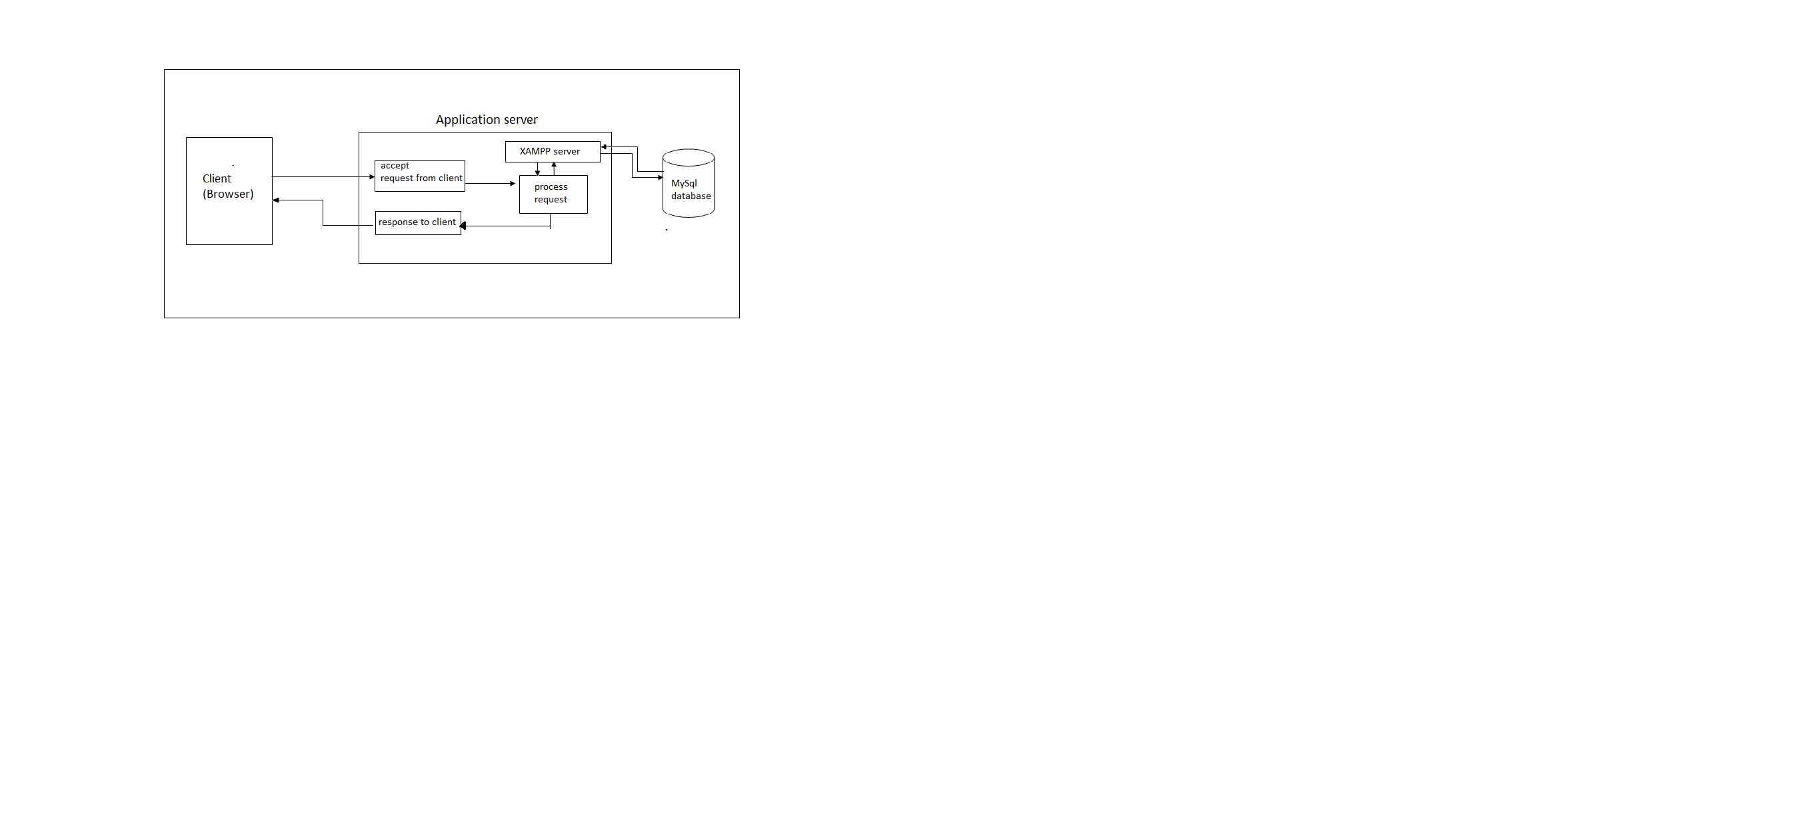

**2.2Software Interface**

**Client on Internet**

Web Browser, Operating System (any)

**Client on Intranet**

Web Browser, Operating System (any)

**Web Server**

XAMPP, Operating System (any)

**Data Base Server**

MySQL, Operating System (any)

**Development End**

HTML, CSS,javascript, MySQL, PHP,OS (Windows),phpmyadmin[admin tool]

**2.3Hardware Interface**

Minimum Requirements

|  |  |  |  |
| --- | --- | --- | --- |
| **Client Side** | | | |
|  | **Processor** | **RAM** | **Disk Space** |
| **Internet Explorer**  **6.0** | Intel Pentium III or AMD -  800 MHz | 128 MB | 100MB |
| **Server Side** | | | |
| **Xampp** | Pentium iii | 512 MB | 1GB |
| **MySQL** | Pentium iii | 512 MB | 1GB (Excluding  data size) |

* 1. **Communication Interface**
* Client (customer) on Internet will be using HTTP/HTTPS protocol.
* Client (system user) on Internet will be using HTTP/HTTPS protocol.
  1. **Constraints**
* GUI is only in English
* Pay cash on delivery
* Regions covered(Delhi and NCR regions)
* Discount over Rs500 purchase
* Login and password is used for identification of users
* Only registered users can purchase books
* Searching of books by title name only

(In ADMIN Task)

* Alert show when availability of books in stock is less than 10
  1. ER Diagram

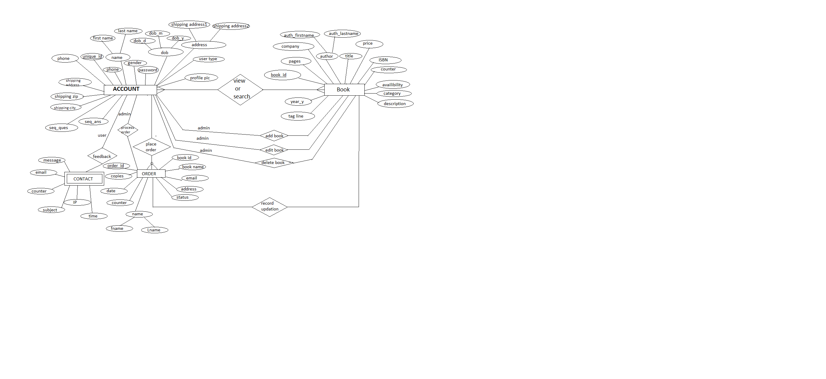

* 1. Data Flow Diagrams
* Context Level Diagram

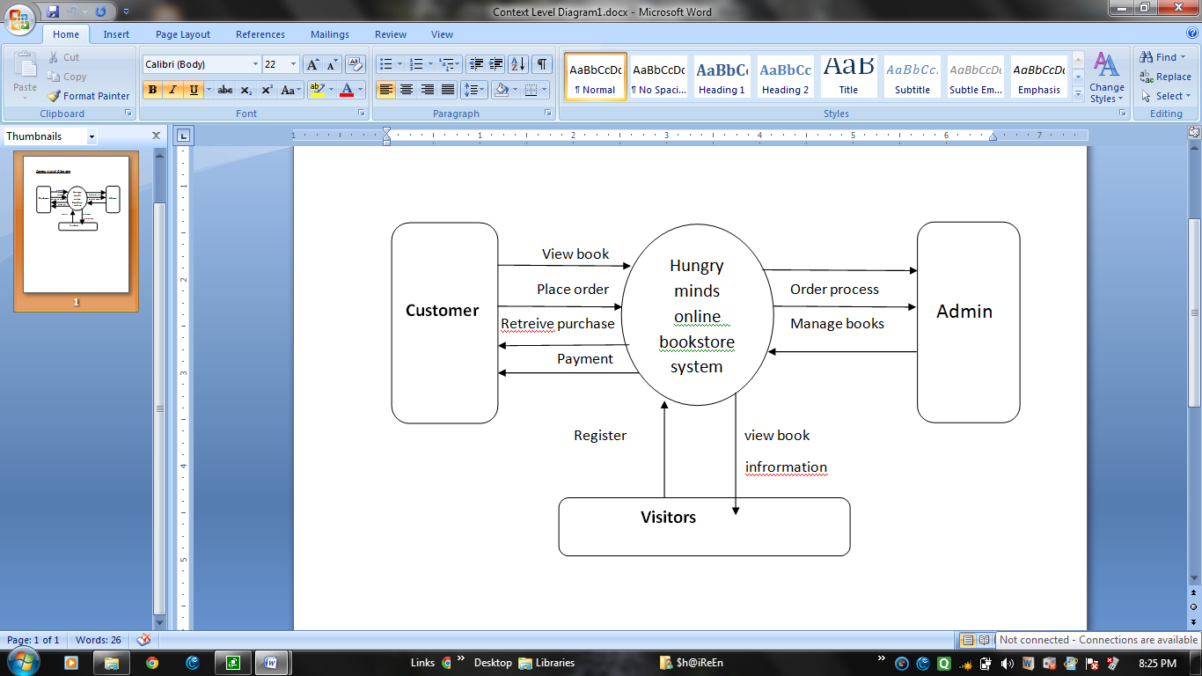

**Library Management**

**System**

* Level 1 DFD

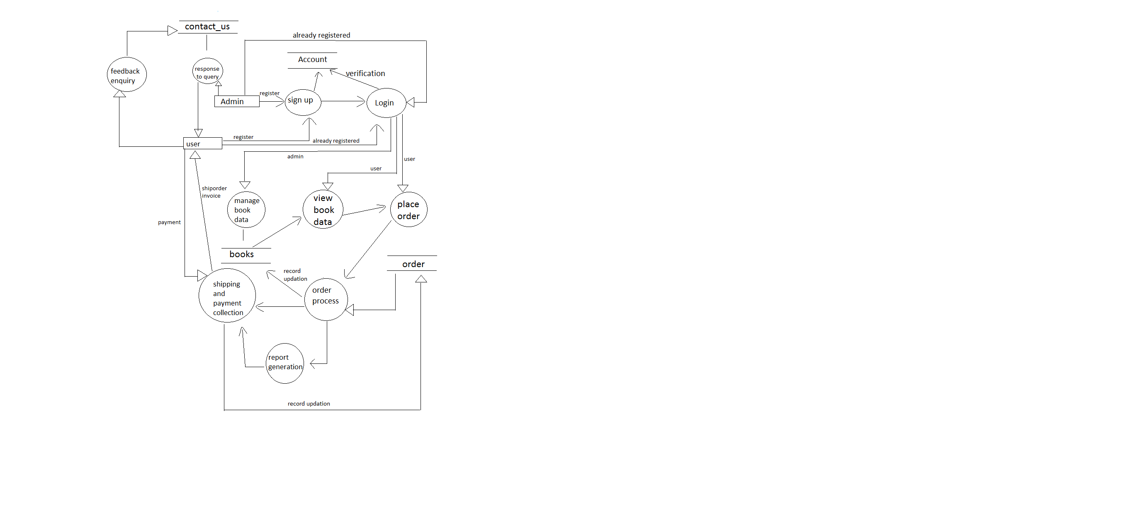

* Level 2 DFDs

1. **Login:-**

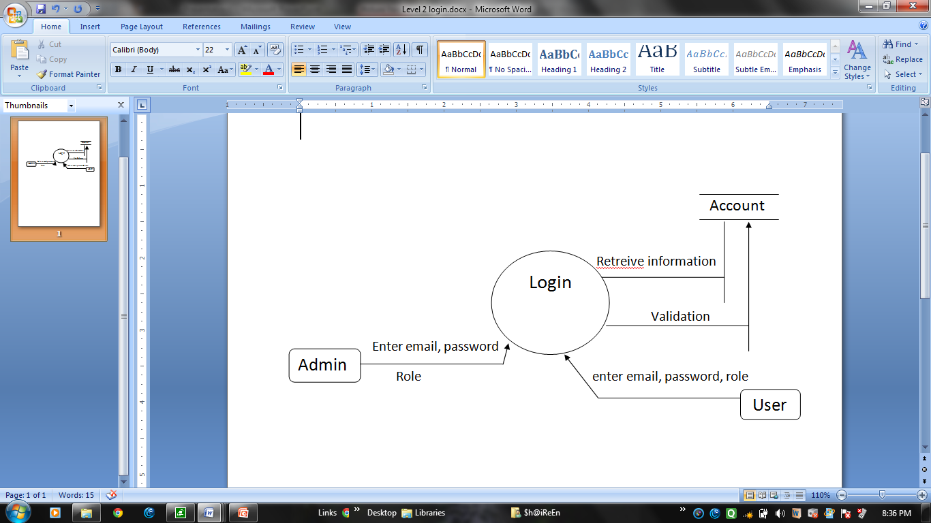

**2.Book Data Management:-**

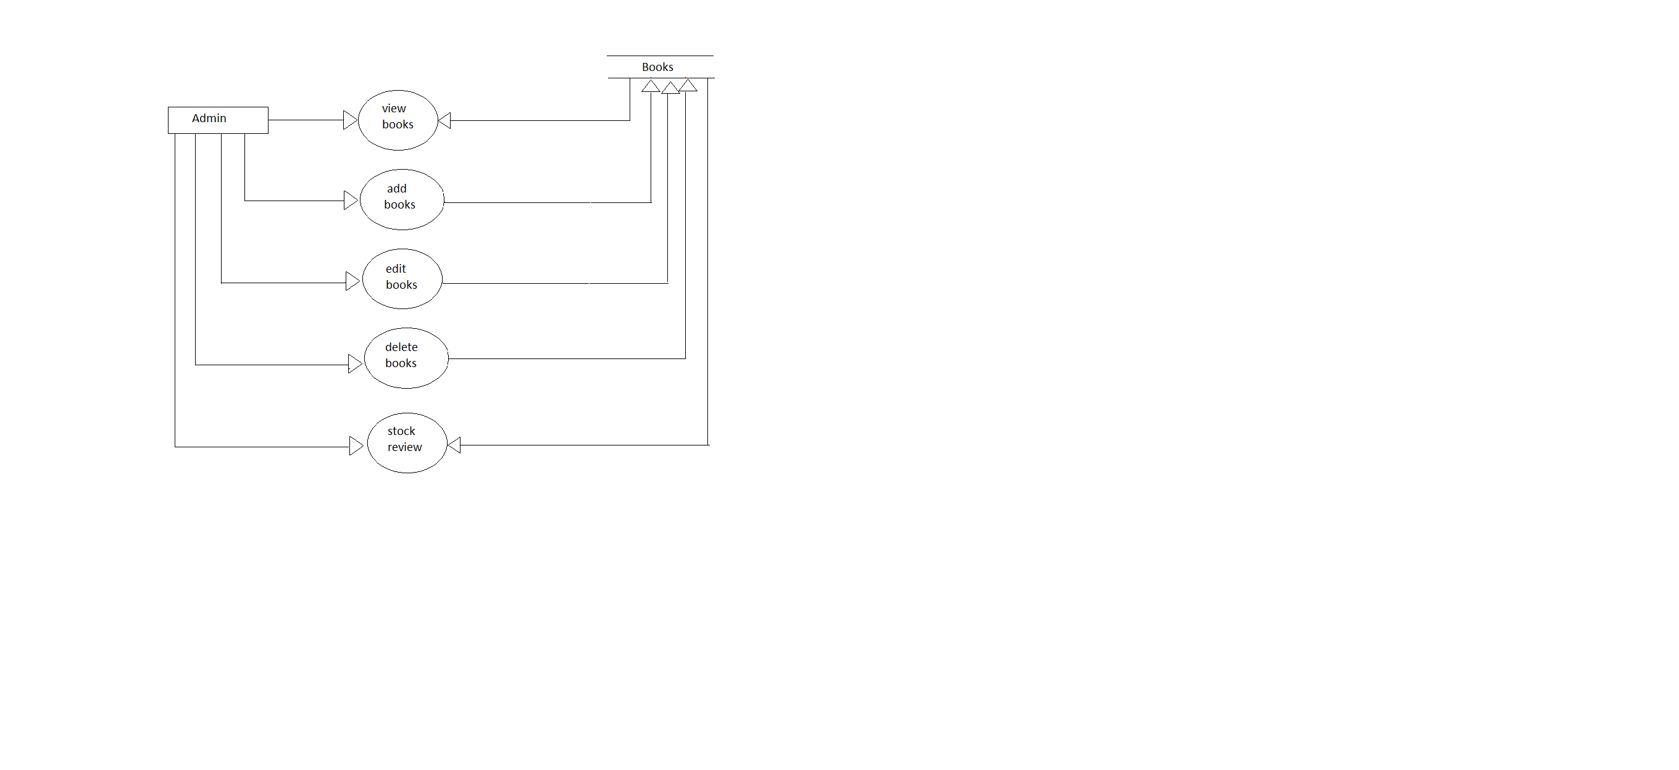

**3.Order Process Management:-**

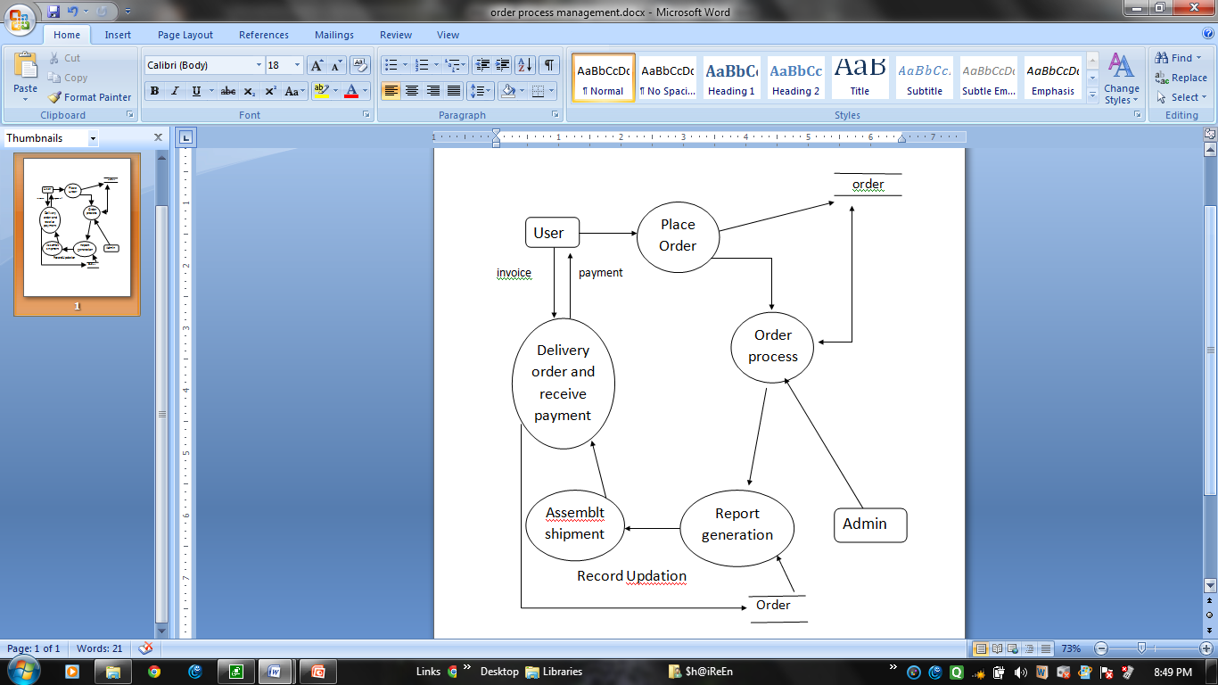

**4.Order place by User:-**

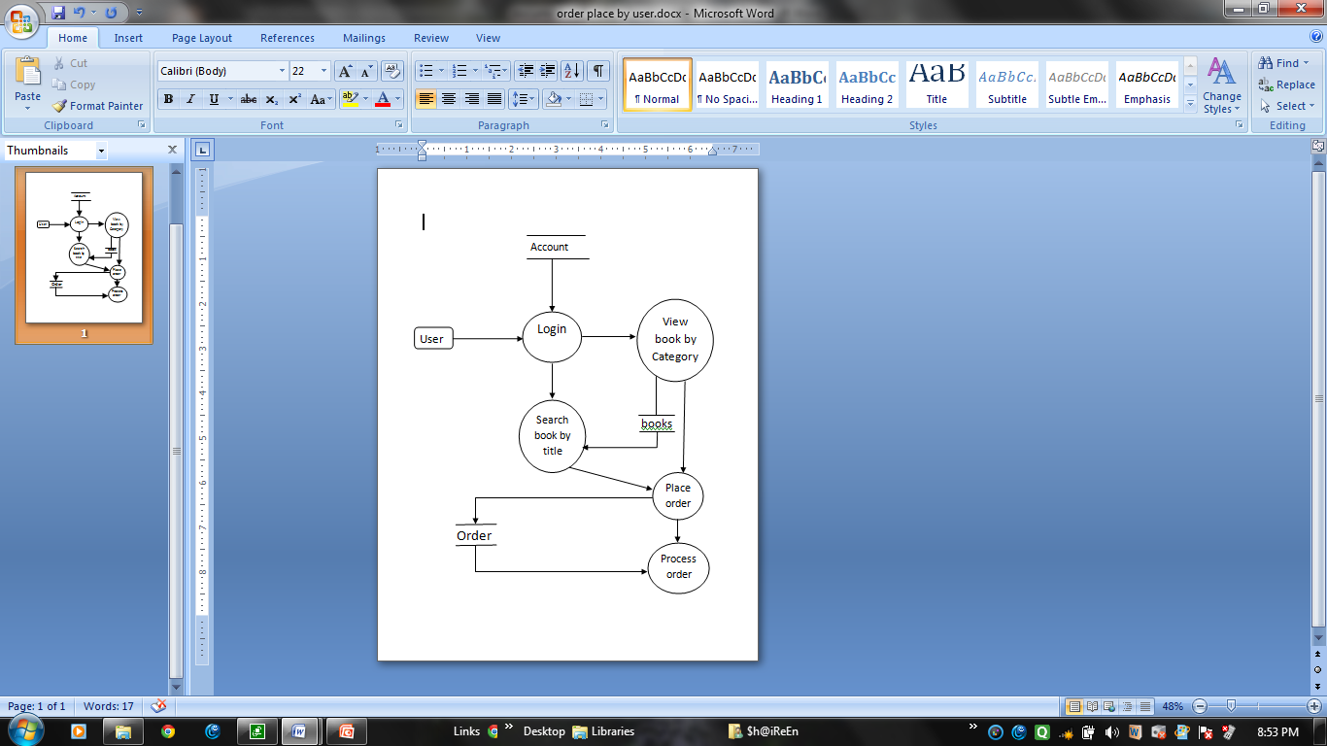

**5.Feedback/Contact/Suggestion by User:-**

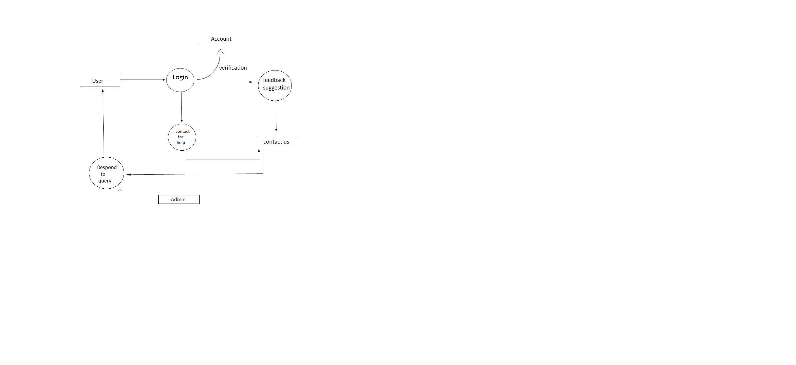

**6.Check Order Status:-**

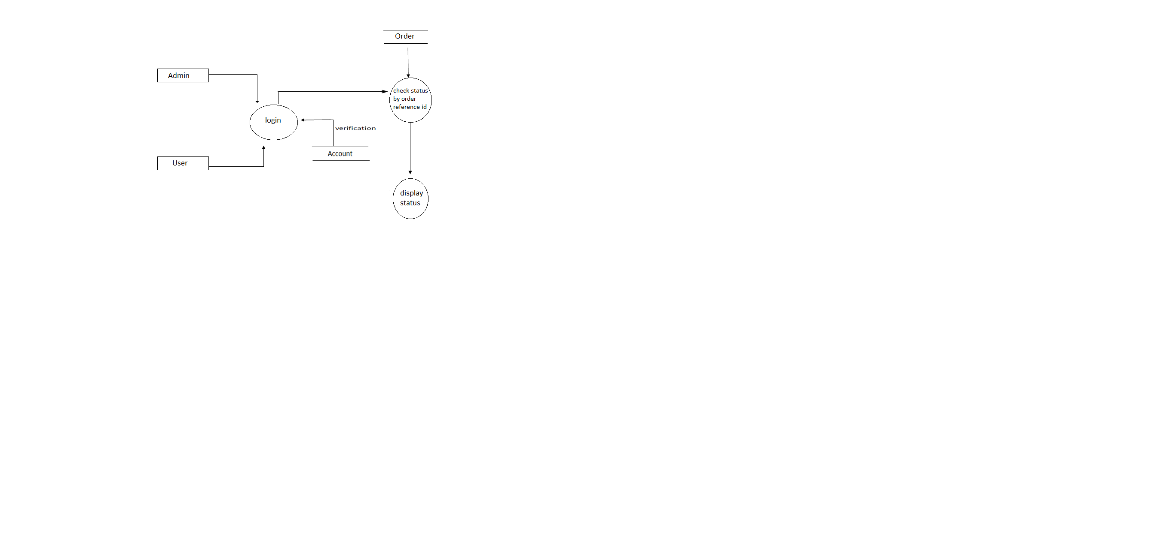

* 1. Architecture Design

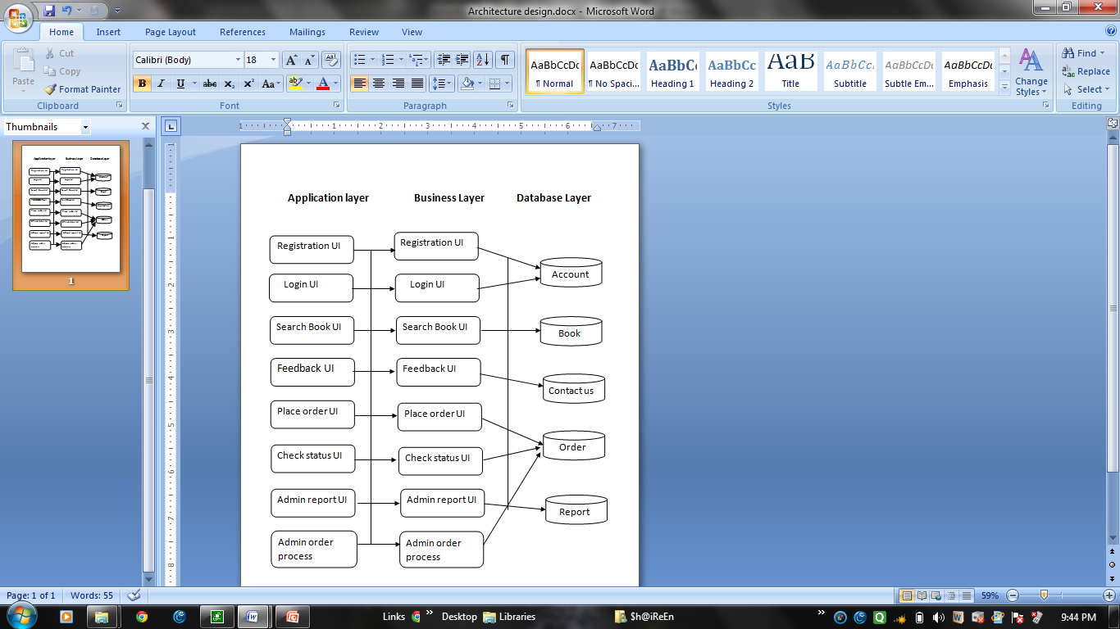

**CONDIGN & FORMS**

**3. CONDIGN & FORMS**

Home Page

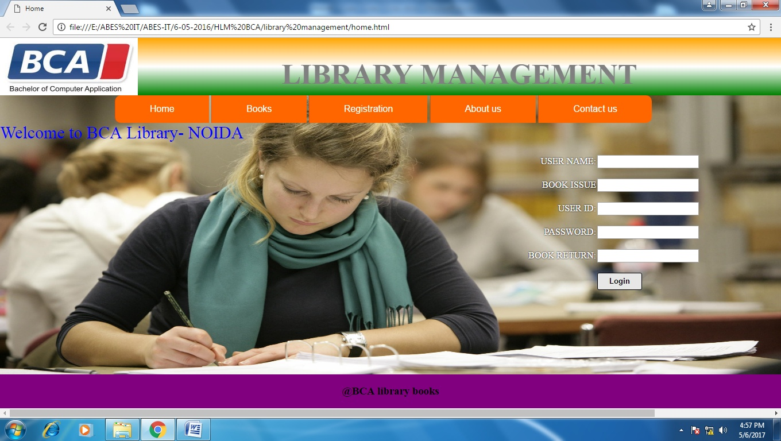

|  |  |
| --- | --- |
|  | <html> |
|  | <head> |
|  | <title>Home</title> |
|  | <link rel="stylesheet" type="text/css" href="style/style.css"> |
|  | </head> |
|  |  |
|  | <body style="background-image:url(images/background.jpg)"> |
|  | <header> |
|  | <div class="header"> |
|  | <div id="left"> |
|  | <img src="images/bca.jpg" height=100px width=240px> |
|  | </div> |
|  | <div id="center"><h1>LIBRARY MANAGEMENT</h1></div> |
|  |  |
|  | </div> |
|  | <div class="container"> |
|  | <nav> |
|  | <ul id="main-nav"> |
|  | <li><a href="fome.html">Home</a></li> |
|  | <li><a href="#">Books</a> |
|  | <ul class="subnav"> |
|  | <li><a href="sem1.html">semester I</a></li> |
|  | <li><a href="sem2.html">semester II</a></li> |
|  | <li><a href="sem3.html">semester III</a></li> |
|  | <li><a href="sem4.html">semester IV</a></li> |
|  | <li><a href="sem5.html">semester V</a></li> |
|  | <li><a href="sem6.html">semester VI</a></li> |
|  | </ul> |
|  | </li> |
|  | <li><a href="registration.html">Registration</a></li> |
|  | <li><a href="about.html"> About us </a></li> |
|  | <li><a href="contact.html">Contact us</a></li> |
|  | </ul> |
|  | </nav> |
|  | </div> |
|  | </header> |
|  | <simplebanner bgcolor="pink"> |
|  | <span class="style2">Welcome to BCA Library- NOIDA</span> |
|  | </simplebanner> |
|  | <form class="mainform" method="post"> |
|  | <div class="form"> |
|  | <label for="user">USER NAME:</label><input type="text" id="user" name="user"><br/><br/> |
|  | </div> |
|  | <div class="form"> |
|  | <label for="user">BOOK ISSUE</label><input type="text" id="user" name="user"><br/><br/> |
|  | </div> |
|  | <div class="form"> |
|  | <label for="id">USER ID:</label><input type="text" id="id" name="id"><br/><br/> |
|  | </div> |
|  | <div class="form"> |
|  | <label for="pass">PASSWORD:</label><input type="password" id="pass" name="pass"><br/><br/> |
|  | </div> |
|  | <div class="form"> |
|  | <label for="user">BOOK RETURN:</label><input type="text" id="user" name="user"><br/><br/> |
|  | </div> |
|  | <div class="form"> |
|  | <label for="login"></label><a href="index1.html"><input type="button" id="login" name="login" value="Login" ></a> |
|  | </div> |
|  | </p> |
|  | </form> |
|  | </header> |
|  | <body> |
|  |  |
|  |  |
|  |  |
|  | <footer> |
|  | <h3>@BCA library books</h3> |
|  | </footer> |
|  | </body> |
|  |  |
|  |  |
|  |  |
|  |  |
|  |  |
|  |  |
|  |  |
|  |  |
|  |  |
|  |  |
|  |  |
|  |  |
|  |  |
|  |  |
|  |  |
|  | </html> |

About Us

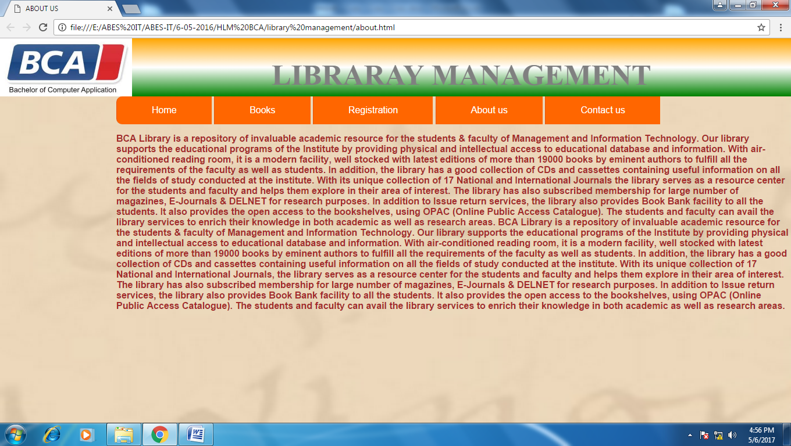

|  |  |
| --- | --- |
|  | <html> |
|  | <head> |
|  | <title>ABOUT US</title> |
|  | <link rel="stylesheet" type="text/css" href="style/style.css"> |
|  | </head> |
|  | <body style="background-image:url(images/body.jpg)"> |
|  | <header> |
|  | <div class="header"> |
|  | <div id="left"> |
|  | <img src="images/bca.jpg"height=100px,width=240px> |
|  | </div> |
|  | <div id="center"><h1>LIBRARAY MANAGEMENT</h1> |
|  | </div> |
|  | </div> |
|  | <div class="container"> |
|  | <nav> |
|  | <ul id="main-nav"> |
|  | <li><a href="home.html">Home</a></li> |
|  | <li><a href="#">Books</a> |
|  | <ul class="subnav"> |
|  | <li><a href="sem1.html">semester I</a></li> |
|  | <li><a href="sem2.html">semester II</a></li> |
|  | <li><a href="sem3.html">semester III</a></li> |
|  | <li><a href="sem4.html">semester IV</a></li> |
|  | <li><a href="sem5.html">semester V</a></li> |
|  | <li><a href="sem6.html">semester VI</a></li> |
|  | </ul> |
|  | </li> |
|  | <li><a href="registration.html">Registration</a></li> |
|  | <li><a href="about.html"> About us</a></li> |
|  | <li><a href="contact.html">Contact us</a></li> |
|  | <div class="about"><p ><b> BCA Library is a repository of invaluable academic resource for the students & faculty |
|  | of Management and Information Technology. Our library supports the educational programs of the Institute by providing |
|  | physical and intellectual access to educational database and information. With air-conditioned reading room, |
|  | it is a modern facility, well stocked with latest editions of more than 19000 books by eminent authors to fulfill all the requirements of the faculty as well as students. In addition, the library has a good collection of CDs and cassettes containing useful information on all the fields of study conducted at the institute. |
|  | With its unique collection of 17 National and International Journals the library serves as a resource center for the students |
|  | and faculty and helps them explore in their area of interest. The library has also subscribed membership for large number of |
|  | magazines, E-Journals & DELNET for research purposes. In addition to Issue return services, the library also provides Book Bank |
|  | facility to all the students. It also provides the open access to the bookshelves, using OPAC (Online Public Access Catalogue). |
|  | The students and faculty can avail the library services to enrich their knowledge in both academic as well as research areas. |
|  | BCA Library is a repository of invaluable academic resource for the students & faculty of Management and Information Technology. |
|  | Our library supports the educational programs of the Institute by providing physical and intellectual access to educational |
|  | database and information. With air-conditioned reading room, it is a modern facility, well stocked with latest editions of more |
|  | than 19000 books by eminent authors to fulfill all the requirements of the faculty as well as students. In addition, the library |
|  | has a good collection of CDs and cassettes containing useful information on all the fields of study conducted at the institute. |
|  | With its unique collection of 17 National and International Journals, the library serves as a resource center for the students |
|  | and faculty and helps them explore in their area of interest. The library has also subscribed membership for large number of |
|  | magazines, E-Journals & DELNET for research purposes. In addition to Issue return services, the library also provides Book Bank |
|  | facility to all the students. It also provides the open access to the bookshelves, using OPAC (Online Public Access Catalogue). |
|  | The students and faculty can avail the library services to enrich their knowledge in both academic as well as research areas. |
|  | </b></p> |
|  | </div> |
|  | </ul> |
|  | </nav> |
|  | </div> |
|  | </header> |
|  | </body> |
|  | </html> |
|  |  |

Index

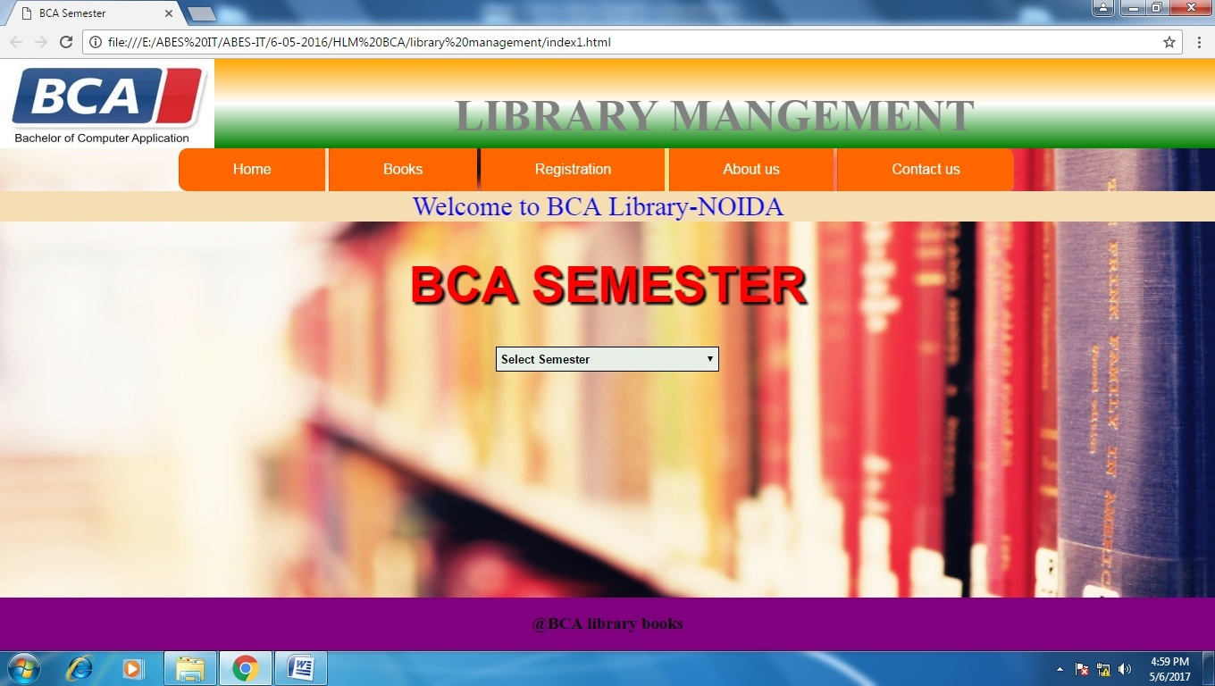

|  |  |
| --- | --- |
|  | <html> |
|  | <head> |
|  | <title>BCA Semester</title> |
|  | <link rel="stylesheet" type="text/css" href="style/style.css"> |
|  | </head> |
|  |  |
|  | <body style="background-image:url(images/image1.jpg)"> |
|  | <header> |
|  | <div class="header"> |
|  | <div id="left"> |
|  | <img src="images/bca.jpg" height=100px width=240px> |
|  | </div> |
|  | <div id="center"><h1>LIBRARY MANGEMENT</h1></div> |
|  |  |
|  | </div> |
|  | <div class="container"> |
|  | <nav> |
|  | <ul id="main-nav"> |
|  | <li><a href="home.html">Home</a></li> |
|  | <li><a href="#">Books</a> |
|  | <ul class="subnav"> |
|  | <li><a href="sem1.html">semester I</a></li> |
|  | <li><a href="sem2.html">semester II</a></li> |
|  | <li><a href="sem3.html">semester III</a></li> |
|  | <li><a href="sem4.html">semester IV</a></li> |
|  | <li><a href="sem5.html">semester V</a></li> |
|  | <li><a href="sem6.html">semester VI</a></li> |
|  | </ul> |
|  | </li> |
|  | <li><a href="registration.html">Registration</a></li> |
|  | <li><a href="about.html"> About us</a></li> |
|  | <li><a href="contact.html">Contact us</a></li> |
|  | </ul> |
|  | </nav> |
|  | </div> |
|  | </header> |
|  | <marquee bgcolor="wheat"> |
|  | <span class="style2">Welcome to BCA Library-NOIDA </span> |
|  | </marquee> |
|  | <div class="style1"><h1>BCA SEMESTER</h1></div> |
|  | <form name="Menu1"> |
|  | <div class="style3"><p align="center"><select name="Link" onChange="window.location = document.Menu1.Link.options[document.Menu1.Link.options.selectedIndex].value;"> |
|  | <option >Select Semester</option> |
|  | <option value="sem1.html">Semester I</option> |
|  | <option value="sem2.html">Semester II</option> |
|  | <option value="sem3.html">Semester III</option> |
|  | <option value="sem4.html">Semester IV</option> |
|  | <option value="sem5.html">Semester V</option> |
|  | <option value="sem6.html">Semester VI</option> |
|  | </select> |
|  | </p> |
|  | </div> |
|  |  |
|  | </form> |
|  |  |
|  |  |
|  | <footer> |
|  | <h3>@BCA library books</h3> |
|  | </footer> |
|  | </body> |
|  |  |
|  | </html> |

**REGISTRATION**

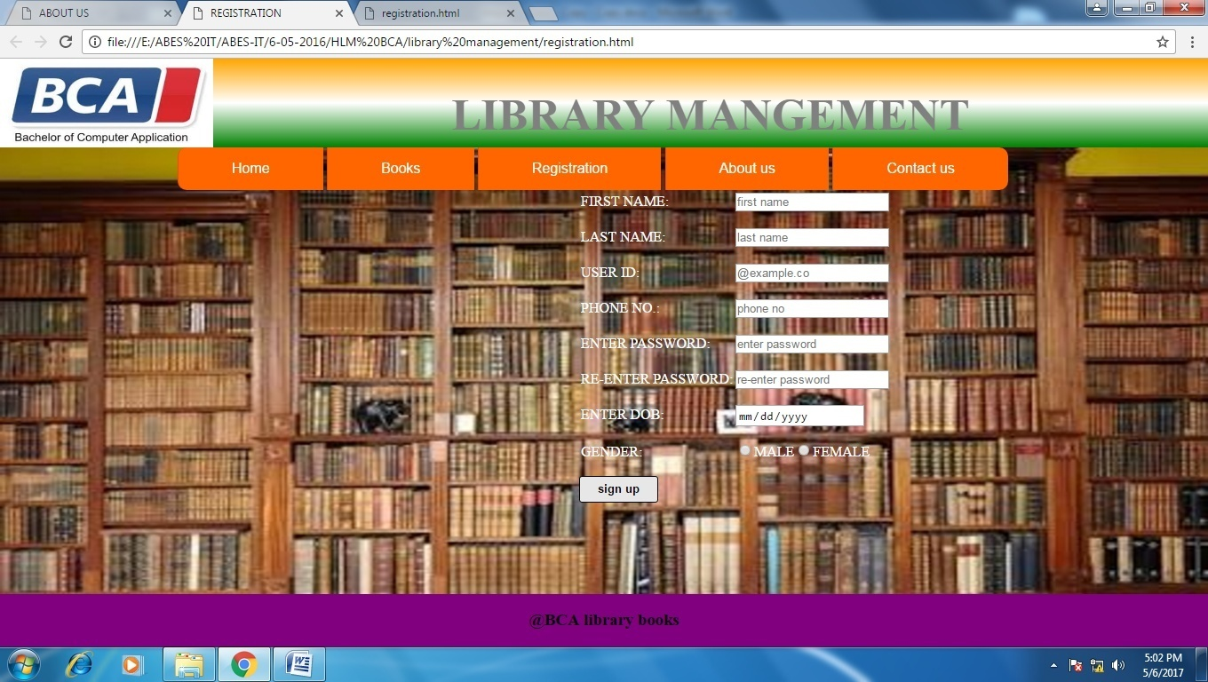

|  |  |
| --- | --- |
|  | <html> |
|  | <head> |
|  | <title>REGISTRATION</title> |
|  | <link rel="stylesheet" type="text/css" href="style/style.css"> |
|  | </head> |
|  |  |
|  | <body style="background-image:url(images/images.jpg)"> |
|  | <header> |
|  | <div class="header"> |
|  | <div id="left"> |
|  | <img src="images/bca.jpg" height=100px width=240px> |
|  | </div> |
|  | <div id="center"><h1>LIBRARY MANGEMENT</h1></div> |
|  |  |
|  | </div> |
|  | <div class="container"> |
|  | <nav> |
|  | <ul id="main-nav"> |
|  | <li><a href="home.html">Home</a></li> |
|  | <li><a href="#">Books</a> |
|  | <ul class="subnav"> |
|  | <li><a href="sem1.html">semester I</a></li> |
|  | <li><a href="sem2.html">semester II</a></li> |
|  | <li><a href="sem3.html">semester III</a></li> |
|  | <li><a href="sem4.html">semester IV</a></li> |
|  | <li><a href="sem5.html">semester V</a></li> |
|  | <li><a href="sem6.html">semester VI</a></li> |
|  | </ul> |
|  | </li> |
|  | <li><a href="registration.html">Registration</a></li> |
|  | <li><a href="about.html"> About us</a></li> |
|  | <li><a href="contact.html">Contact us</a></li> |
|  | </ul> |
|  | </nav> |
|  | </div> |
|  | </header> |
|  | <content> |
|  | <div> |
|  | <form class="reg" method="post"> |
|  | <div class="row"><label for="first">FIRST NAME:</label><input type="text" id="first" name="first" placeholder="first name"><br/><br/></div> |
|  | <div class="row"><label for="last">LAST NAME:</label><input type="text" id="last" name="last" placeholder="last name"><br><br></div> |
|  | <div class="row"><label for="id">USER ID:</label><input type="text" id="id" name="id" placeholder="@example.co"><br><br></div> |
|  | <div class="row"><label for="id">PHONE NO.:</label><input type="text" id="id" name="id" placeholder="phone no"><br><br></div> |
|  | <div class="row"><label for="pass">ENTER PASSWORD:</label><input type="password" id="pass" name="pass" placeholder="enter password"><br><br></div> |
|  | <div class="row"><label for="repass">RE-ENTER PASSWORD:</label><input type="password" id="repass" name="repass" placeholder="re-enter password"><br><br></div> |
|  | <div class="row"><label for="dob">ENTER DOB:</label><input type="DATE" id="dob" name="dob"><br><br></div> |
|  | <div class="row"><label for="gender">GENDER:</label><input type="radio" id="gender" name="gender">MALE<input type="radio" id="gender" name="gender">FEMALE<br><br></div> |
|  | <div class="row"><input type="button" id="sign up" name="sign up" value="sign up"></div> |
|  | </form> |
|  | </div> |
|  | </content> |
|  |  |
|  | <footer> |
|  | <h3>@BCA library books</h3> |
|  | </footer> |
|  | </body> |
|  |  |
|  | </html> |

1 Sem.

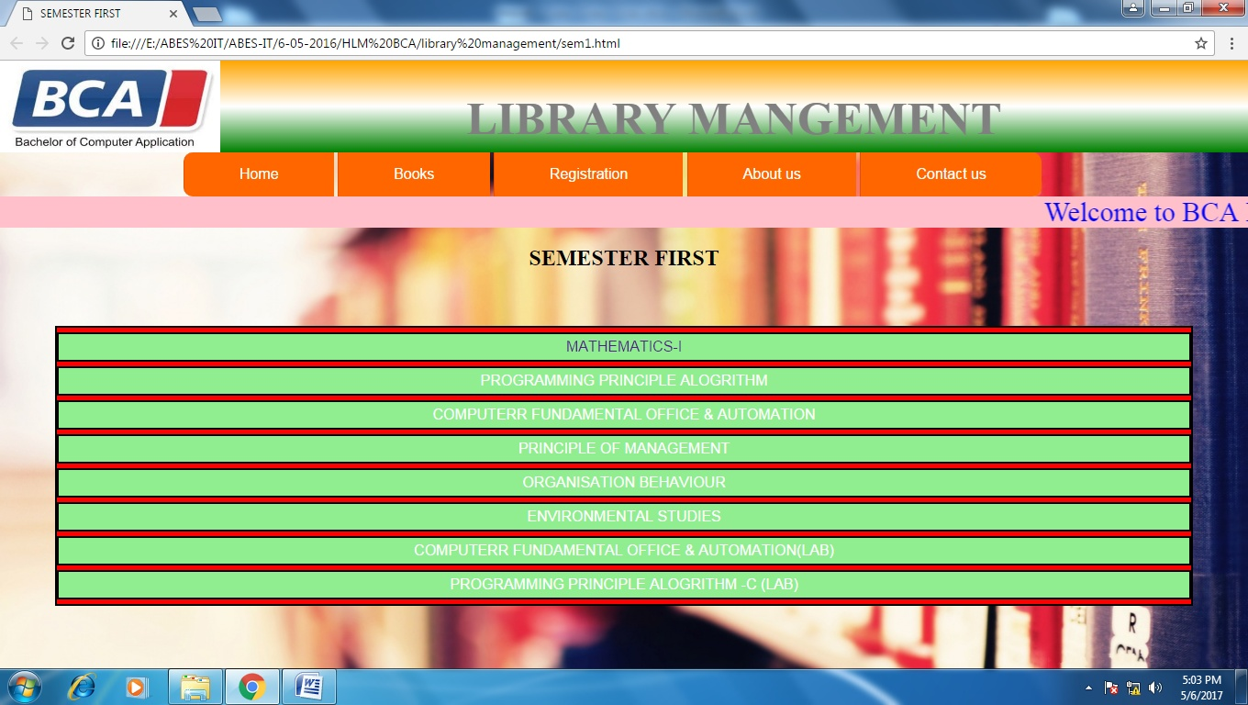

|  |  |
| --- | --- |
|  | <html> |
|  | <head> |
|  | <title>SEMESTER FIRST</title> |
|  | <link rel="stylesheet" type="text/css" href="style/style.css"> |
|  | </head> |
|  | <body style="background-image:url(images/image1.jpg)"> |
|  | <header> |
|  | <div class="header"> |
|  | <div id="left"> |
|  | <img src="images/bca.jpg" height=100px width=240px> |
|  | </div> |
|  | <div id="center"><h1>LIBRARY MANGEMENT</h1></div> |
|  |  |
|  | </div> |
|  | <div class="container"> |
|  | <nav> |
|  | <ul id="main-nav"> |
|  | <li><a href="home.html">Home</a></li> |
|  | <li><a href="#">Books</a> |
|  | <ul class="subnav"> |
|  | <li><a href="sem1.html">semester I</a></li> |
|  | <li><a href="sem2.html">semester II</a></li> |
|  | <li><a href="sem3.html">semester III</a></li> |
|  | <li><a href="sem4.html">semester IV</a></li> |
|  | <li><a href="sem5.html">semester V</a></li> |
|  | <li><a href="sem6.html">semester VI</a></li> |
|  | </ul> |
|  | </li> |
|  | <li><a href="registration.html">Registration</a></li> |
|  | <li><a href="about.html"> About us </a></li> |
|  | <li><a href="contact.html">Contact us</a></li> |
|  | </ul> |
|  | </nav> |
|  | </div> |
|  | </header> |
|  | <marquee bgcolor="pink"> |
|  | <span class="style2">Welcome to BCA Library- NOIDA</span> |
|  | </marquee> |
|  | <center><h2>SEMESTER FIRST</h2> |
|  | </div> |
|  | <div class="sem_list"> |
|  | <ol> |
|  |  |
|  | <li><a href="images/math3.jpg">MATHEMATICS-I</a></li> |
|  | <li>PROGRAMMING PRINCIPLE ALOGRITHM</li> |
|  | <li>COMPUTERR FUNDAMENTAL OFFICE & AUTOMATION</li> |
|  | <li>PRINCIPLE OF MANAGEMENT</li> |
|  | <li>ORGANISATION BEHAVIOUR</li> |
|  | <lI>ENVIRONMENTAL STUDIES</li> |
|  | <li>COMPUTERR FUNDAMENTAL OFFICE & AUTOMATION(LAB)</li> |
|  | <li>PROGRAMMING PRINCIPLE ALOGRITHM -C (LAB) </li> |
|  | </ol> |
|  |  |
|  | </div> |
|  | </body> |
|  | </html> |

Semester-II

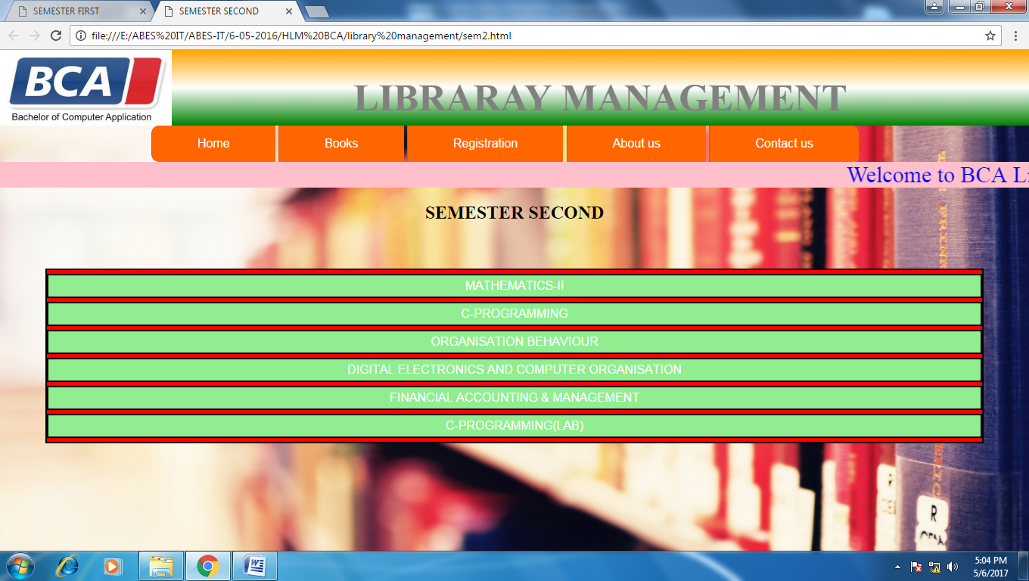

|  |  |
| --- | --- |
|  | <html> |
|  | <head> |
|  | <title>SEMESTER SECOND</title> |
|  | <link rel="stylesheet" type="text/css" href="style/style.css"> |
|  |  |
|  | </head> |
|  |  |
|  | <body style="background-image:url(images/image1.jpg)"> |
|  | <header> |
|  | <div class="header"> |
|  | <div id="left"> |
|  | <img src="images/bca.jpg"height=100px,width=240px> |
|  | </div> |
|  | <div id="center"><h1>LIBRARAY MANAGEMENT</h1> |
|  | </div> |
|  | </div> |
|  | <div class="container"> |
|  | <nav> |
|  | <ul id="main-nav"> |
|  | <li><a href="home.html">Home</a></li> |
|  | <li><a href="#">Books</a> |
|  | <ul class="subnav"> |
|  | <li><a href="sem1.html">semester I</a></li> |
|  | <li><a href="sem2.html">semester II</a></li> |
|  | <li><a href="sem3.html">semester III</a></li> |
|  | <li><a href="sem4.html">semester IV</a></li> |
|  | <li><a href="sem5.html">semester V</a></li> |
|  | <li><a href="sem6.html">semester VI</a></li> |
|  | </ul> |
|  | </li> |
|  | <li><a href="registration.html">Registration</a></li> |
|  | <li><a href="about.html"> About us</a></li> |
|  | <li><a href="contact.html">Contact us</a></li> |
|  | </ul> |
|  | </nav> |
|  | </div> |
|  |  |
|  | </header> |
|  | <marquee bgcolor="pink"> |
|  | <span class="style2">Welcome to BCA Library- NOIDA</span> |
|  | </marquee> |
|  | <center><h2>SEMESTER SECOND</h2> |
|  | </div> |
|  | <div class="sem_list"> |
|  | <ol> |
|  | <li>MATHEMATICS-II</li> |
|  | <li>C-PROGRAMMING</li> |
|  | <li>ORGANISATION BEHAVIOUR</li> |
|  | <li>DIGITAL ELECTRONICS AND COMPUTER ORGANISATION</li> |
|  | <li>FINANCIAL ACCOUNTING & MANAGEMENT</li> |
|  | <li>C-PROGRAMMING(LAB)</li> |
|  | </ol> |
|  | </div> |
|  |  |
|  |  |
|  | </body> |
|  |  |
|  |  |
|  |  |
|  |  |
|  |  |
|  |  |
|  |  |
|  |  |
|  |  |
|  | </html> |

**Semester Third**

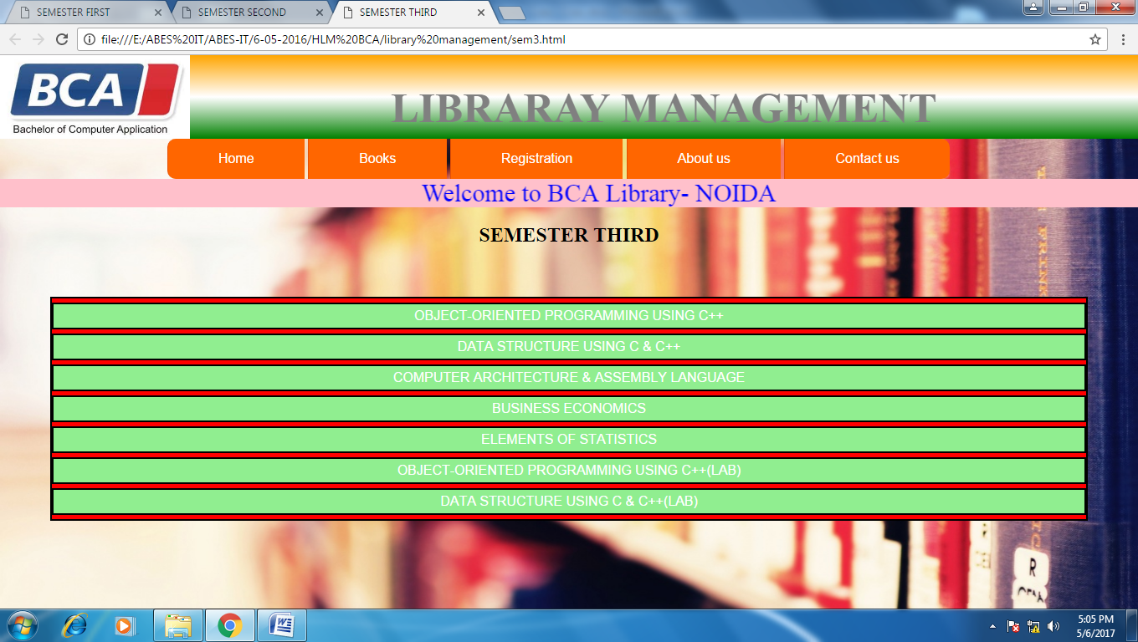

|  |  |
| --- | --- |
|  | <html> |
|  | <head> |
|  | <title>SEMESTER THIRD</title> |
|  | <link rel="stylesheet" type="text/css" href="style/style.css"> |
|  |  |
|  | </head> |
|  |  |
|  | <body style="background-image:url(images/image1.jpg)"> |
|  | <header> |
|  | <div class="header"> |
|  | <div id="left"> |
|  | <img src="images/bca.jpg"height=100px,width=240px> |
|  | </div> |
|  | <div id="center"><h1>LIBRARAY MANAGEMENT</h1> |
|  | </div> |
|  | </div> |
|  | <div class="container"> |
|  | <nav> |
|  | <ul id="main-nav"> |
|  | <li><a href="home.html">Home</a></li> |
|  | <li><a href="#">Books</a> |
|  | <ul class="subnav"> |
|  | <li><a href="sem1.html">semester I</a></li> |
|  | <li><a href="sem2.html">semester II</a></li> |
|  | <li><a href="sem3.html">semester III</a></li> |
|  | <li><a href="sem4.html">semester IV</a></li> |
|  | <li><a href="sem5.html">semester V</a></li> |
|  | <li><a href="sem6.html">semester VI</a></li> |
|  | </ul> |
|  | </li> |
|  | <li><a href="registration.html">Registration</a></li> |
|  | <li><a href="about.html"> About us</a></li> |
|  | <li><a href="contact.html">Contact us</a></li> |
|  | </ul> |
|  | </nav> |
|  | </div> |
|  |  |
|  | </header> |
|  | <marquee bgcolor="pink"> |
|  | <span class="style2">Welcome to BCA Library- NOIDA</span> |
|  | </marquee> |
|  | <center><h2>SEMESTER THIRD</h2> |
|  | </div> |
|  | <div class="sem_list"> |
|  | <ol> |
|  | <li>OBJECT-ORIENTED PROGRAMMING USING C++</li> |
|  | <li>DATA STRUCTURE USING C & C++</li> |
|  | <li>COMPUTER ARCHITECTURE & ASSEMBLY LANGUAGE</li> |
|  | <li>BUSINESS ECONOMICS</li> |
|  | <li>ELEMENTS OF STATISTICS</li> |
|  | <li>OBJECT-ORIENTED PROGRAMMING USING C++(LAB)</li> |
|  | <li>DATA STRUCTURE USING C & C++(LAB)</li> |
|  | </ol> |
|  | </div> |
|  |  |
|  |  |
|  | </body> |
|  | </html> |

Semester Fourth

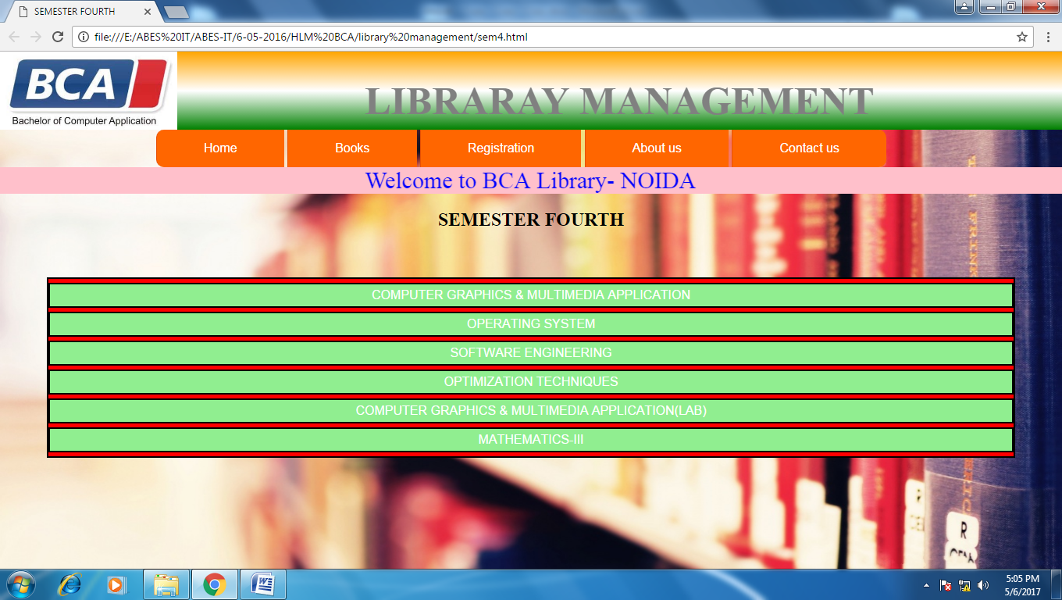

|  |  |
| --- | --- |
|  | <html> |
|  | <head> |
|  | <title>SEMESTER FOURTH</title> |
|  | <link rel="stylesheet" type="text/css" href="style/style.css"> |
|  |  |
|  | </head> |
|  |  |
|  | <body style="background-image:url(images/image1.jpg)"> |
|  | <header> |
|  | <div class="header"> |
|  | <div id="left"> |
|  | <img src="images/bca.jpg"height=100px,width=240px> |
|  | </div> |
|  | <div id="center"><h1>LIBRARAY MANAGEMENT</h1> |
|  | </div> |
|  | </div> |
|  | <div class="container"> |
|  | <nav> |
|  | <ul id="main-nav"> |
|  | <li><a href="home.html">Home</a></li> |
|  | <li><a href="#">Books</a> |
|  | <ul class="subnav"> |
|  | <li><a href="sem1.html">semester I</a></li> |
|  | <li><a href="sem2.html">semester II</a></li> |
|  | <li><a href="sem3.html">semester III</a></li> |
|  | <li><a href="sem4.html">semester IV</a></li> |
|  | <li><a href="sem5.html">semester V</a></li> |
|  | <li><a href="sem6.html">semester VI</a></li> |
|  | </ul> |
|  | </li> |
|  | <li><a href="registration.html">Registration</a></li> |
|  | <li><a href="About.html"> About us </a></li> |
|  | <li><a href="contact.html">Contact us</a></li> |
|  | </ul> |
|  | </nav> |
|  | </div> |
|  |  |
|  | </header> |
|  | <marquee bgcolor="pink"> |
|  | <span class="style2">Welcome to BCA Library- NOIDA</span> |
|  | </marquee> |
|  | <center><h2>SEMESTER FOURTH</h2> |
|  | </div> |
|  | <div class="sem_list"> |
|  | <ol> |
|  | <li>COMPUTER GRAPHICS & MULTIMEDIA APPLICATION</li> |
|  | <li>OPERATING SYSTEM</li> |
|  | <li>SOFTWARE ENGINEERING</li> |
|  | <li>OPTIMIZATION TECHNIQUES</li> |
|  | <li>COMPUTER GRAPHICS & MULTIMEDIA APPLICATION(LAB)</li> |
|  | <li>MATHEMATICS-III</li> |
|  | </ol> |
|  | </div> |
|  |  |
|  |  |
|  | </body> |
|  | </html> |

Semester Fifth

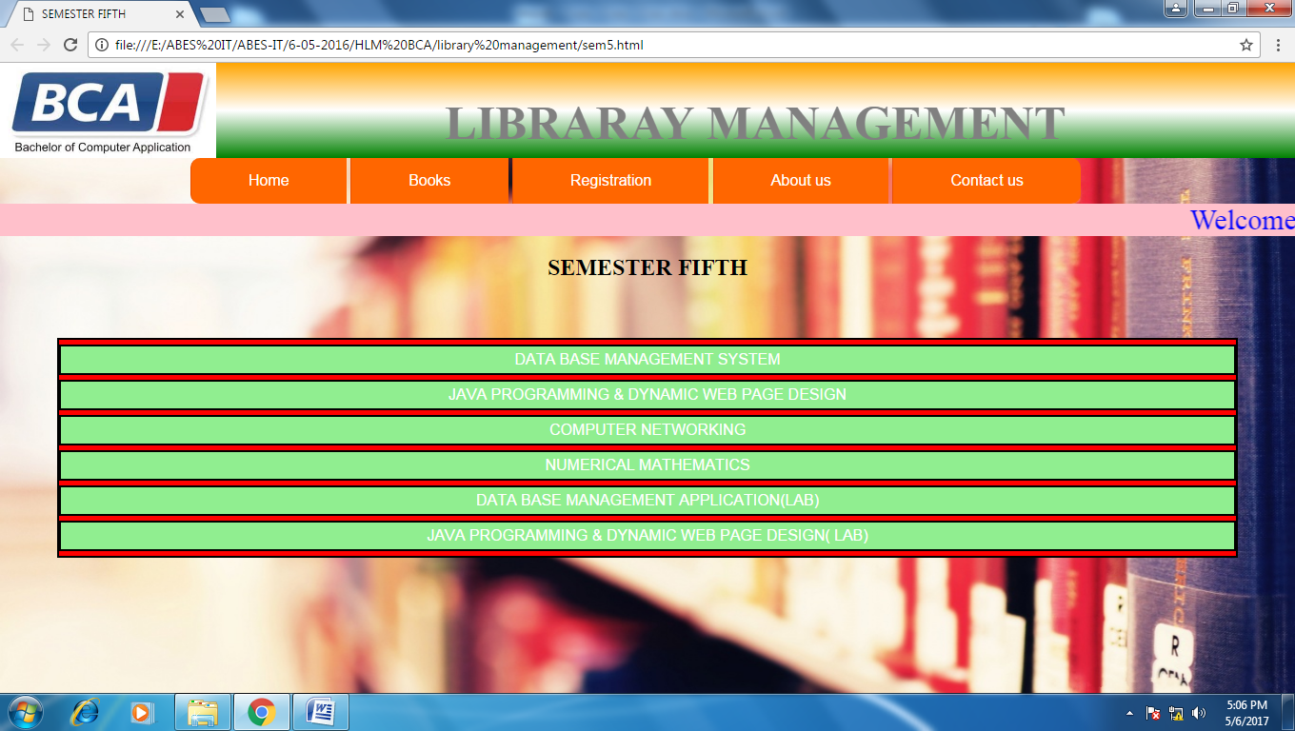

|  |  |
| --- | --- |
|  | <html> |
|  | <head> |
|  | <title>SEMESTER FIFTH</title> |
|  | <link rel="stylesheet" type="text/css" href="style/style.css"> |
|  |  |
|  | </head> |
|  |  |
|  | <body style="background-image:url(images/image1.jpg)"> |
|  | <header> |
|  | <div class="header"> |
|  | <div id="left"> |
|  | <img src="images/bca.jpg"height=100px,width=240px> |
|  | </div> |
|  | <div id="center"><h1>LIBRARAY MANAGEMENT</h1> |
|  | </div> |
|  | </div> |
|  | <div class="container"> |
|  | <nav> |
|  | <ul id="main-nav"> |
|  | <li><a href="home.html">Home</a></li> |
|  | <li><a href="#">Books</a> |
|  | <ul class="subnav"> |
|  | <li><a href="sem1.html">semester I</a></li> |
|  | <li><a href="sem2.html">semester II</a></li> |
|  | <li><a href="sem3.html">semester III</a></li> |
|  | <li><a href="sem4.html">semester IV</a></li> |
|  | <li><a href="sem5.html">semester V</a></li> |
|  | <li><a href="sem6.html">semester VI</a></li> |
|  | </ul> |
|  | </li> |
|  | <li><a href="registration.html">Registration</a></li> |
|  | <li><a href="about.html"> About us</a></li> |
|  | <li><a href="contact.html">Contact us</a></li> |
|  | </ul> |
|  | </nav> |
|  | </div> |
|  |  |
|  | </header> |
|  | <marquee bgcolor="pink"> |
|  | <span class="style2">Welcome to BCA Library- NOIDA</span> |
|  | </marquee> |
|  | <center><h2>SEMESTER FIFTH</h2> |
|  | </div> |
|  | <div class="sem_list"> |
|  | <ol> |
|  | <li>DATA BASE MANAGEMENT SYSTEM</li> |
|  | <li>JAVA PROGRAMMING & DYNAMIC WEB PAGE DESIGN</li> |
|  | <li>COMPUTER NETWORKING</li> |
|  | <li>NUMERICAL MATHEMATICS</li> |
|  | <li>DATA BASE MANAGEMENT APPLICATION(LAB)</li> |
|  | <li>JAVA PROGRAMMING & DYNAMIC WEB PAGE DESIGN( LAB)</li> |
|  | </ol> |
|  | </div> |
|  |  |
|  |  |
|  | </body> |
|  | </html> |

**Semester Sixth**

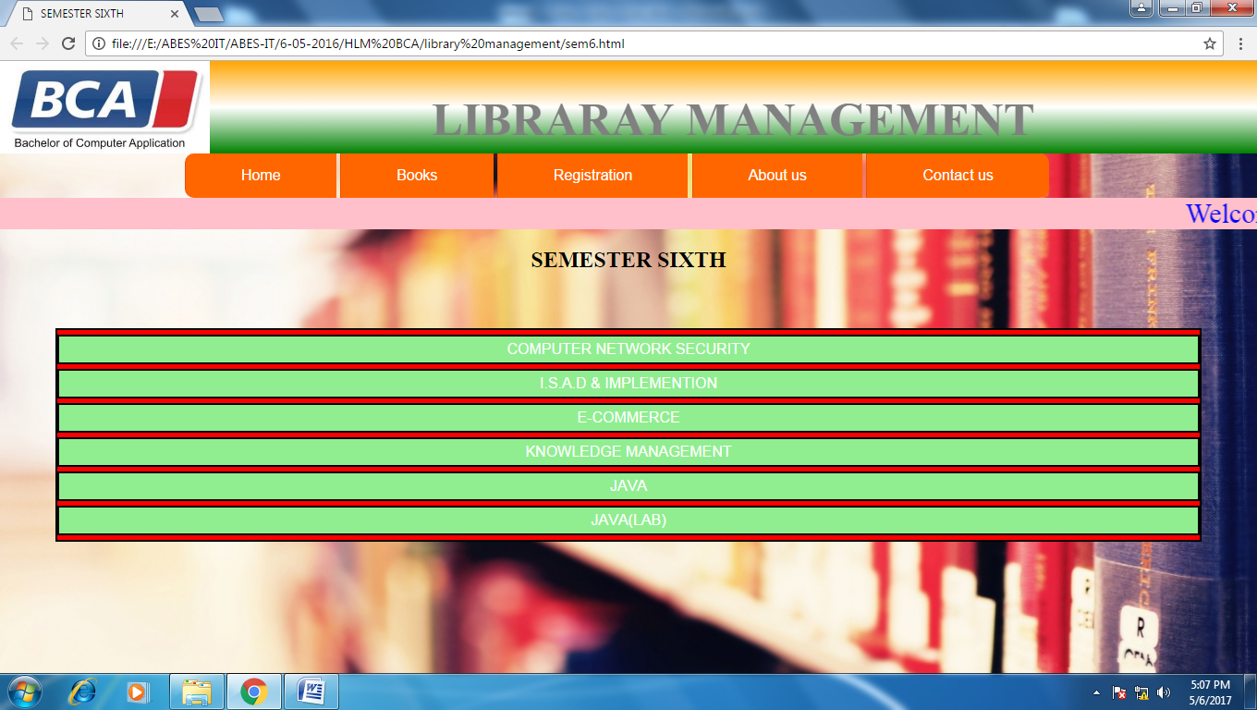

|  |  |
| --- | --- |
|  | <html> |
|  | <head> |
|  | <title>SEMESTER SIXTH</title> |
|  | <link rel="stylesheet" type="text/css" href="style/style.css"> |
|  |  |
|  | </head> |
|  |  |
|  | <body style="background-image:url(images/image1.jpg)"> |
|  | <header> |
|  | <div class="header"> |
|  | <div id="left"> |
|  | <img src="images/bca.jpg"height=100px,width=240px> |
|  | </div> |
|  | <div id="center"><h1>LIBRARAY MANAGEMENT</h1> |
|  | </div> |
|  | </div> |
|  | <div class="container"> |
|  | <nav> |
|  | <ul id="main-nav"> |
|  | <li><a href="home.html">Home</a></li> |
|  | <li><a href="#">Books</a> |
|  | <ul class="subnav"> |
|  | <li><a href="sem1.html">semester I</a></li> |
|  | <li><a href="sem2.html">semester II</a></li> |
|  | <li><a href="sem3.html">semester III</a></li> |
|  | <li><a href="sem4.html">semester IV</a></li> |
|  | <li><a href="sem5.html">semester V</a></li> |
|  | <li><a href="sem6.html">semester VI</a></li> |
|  | </ul> |
|  | </li> |
|  | <li><a href="registration.html">Registration</a></li> |
|  | <li><a href="about.html"> About us </a></li> |
|  | <li><a href="contact.html">Contact us</a></li> |
|  | </ul> |
|  | </nav> |
|  | </div> |
|  |  |
|  | </header> |
|  | <marquee bgcolor="pink"> |
|  | <span class="style2">Welcome to BCA Library- NOIDA</span> |
|  | </marquee> |
|  | <center><h2>SEMESTER SIXTH</h2> |
|  | </div> |
|  | <div class="sem_list"> |
|  | <ol> |
|  | <li>COMPUTER NETWORK SECURITY</li> |
|  | <li>I.S.A.D & IMPLEMENTION</li> |
|  | <li>E-COMMERCE</li> |
|  | <li>KNOWLEDGE MANAGEMENT</li> |
|  | <li>JAVA </li> |
|  | <li>JAVA(LAB)</li> |
|  | </ol> |
|  | </div> |
|  |  |
|  |  |
|  | </body> |
|  | </html> |

**TESTING**

**4. TESTING**

Testing is one of the major hurdles in the development of the system. Testing is the process of fining errors in the system. Only error-free website will be stable for a long time. There are different types of techniques for finding the bugs in website.

System testing is the major quality control measure during software development. A series of test cases are generated that is intended to demolish the software that has been built. Testing is a set activity that can be planned and conducted schematically. Testing begins at the module level and work towards the integration of entire computer based system.

Testing is a process of executing a program with the intention of finding an error. A good test case is one that has a higher probability of finding an undiscovered error. A successful test case is one that uncovers an undiscovered error. Nothing is complete without testing, as it the vital success of the system.

**TESTING OBJECTIVES**

There are several rules that can server as testing objectives. They are

* Testing is a process of executing a program with the intent of finding an error.
* A good test case is one that has high probability of finding an undiscovered error.
* A successful test is one that uncovers an undiscovered error.

If testing is conducted successfully according to the objectives as stated above, it would uncover errors in the software. Generally by testing we are verifying the following three aspects.

* Testing for correctness
* Testing for implementation efficiency
* Testing for computational complexity

**IMPLEMENTATION**

**5. IMPLEMENTATION**

Implementation is the status of the project when the theoretical designs turned into a working system. It is the process of converting a new revised system in to an operational one. It is the key stage in achieving a successful new system because usually it involves a lot of upheaval in the use department. It must therefore carefully plan and controlled so as to avoid chaos.

Apart from planning, the two major task of preparing for implementation are education and training of users and testing of system. Education of users should really have taken place much earlier in the project when they were being involved in the investigation and design work.

The user staff has been given necessary training for using the system. The training has made them to get acquainted with the system. The development any system results in success only when the system is implemented properly.

The purpose of the training is to ensure that all the personnel who are to be associated with the computer based business system possess the necessary knowledge and skills.

**FUTURE ENHANSEMENTS**

6. **FUTURE ENHANSEMENTS**

This library project implements all the basic facilities of library Management when comparing to normal library. Facilities like insurance, corporate library, personal library can be provided. Also we can send alerts to customers through mobile SMS, email services.

But this is just a prototype of library Management project. We can enhance this project as a real time project by adding some additional facilities and enhance the project for future development. As we know in the world noting is constant so is the project.

**CONCLUSION**

**7. CONCLUSION**

The library Management web site successfully implemented and has been found useful. It was also possible to eliminate human errors likely to creep into this kind of work in which bulk quantity of data has to be processed. This application has been designed to suit exact needs. It is user friendly providing graphical user interface. Also this project is flexible for evolution.

**BIBLIOGRAPHY**

**8. BIBLIOGRAPHY**

System Analysis And Design

- Kenneth E. Kendall, Julie E. Kendall

An Analysis and Design of Information Systems

- Grayce M. Booth

Software Engineering ,Testing

- Gopalswamy Ramesh

Database Management System

- Das Gupta , Pranab Kumar

Asp Allinces